

DemandEst- AI Powered Food Demand

Forecaster

# PROJECTREPORT

***Submitted by***

**AAYESHA SITHIKA.A 822419104002**

**ABINAYA.S 822419104004**

**MANJULA.S 822419104023**

**SIVARANJANI.B 822419104042**

***In partial fulfillment for the award of the degree of***

**BACHELOR OF ENGINEERING**

**MRK INSTITUTE OF TECHNOLOGY**

**KATTUMANNARKOIL**

**CUDDALORE,608301.**

**NOV2022**

**MRK INSTITUTE OF TECHNOLOGY**

**KATTUMANNARKOIL,**

**CUDDALORE,608301.**

Department of Computer science and engineering

**BONAFIDE CERTIFICATE**

Certified of this project report**”DemandEst–AI Powered Food DemandForecasater”AAYESHASITHIKA.A(822419104002),ABINAYA.S(822419104004),MANJULA.S(822419104023),SIVARANJANI.B(822419104042).”**who carried out the project work under by supervisor.

**SIGNATURE SIGNATURE**

**Mr.A.AKILAN,M.E., Mr.S.RAMALINGAM,M.E.,**

**HEAD OF THE DEPARTMENT, SUPERVISOR,**

**DEPARTMENT OF CSE, ASSISTANT PROFESSOR,**

**MRK INSTITUTE OF TECHNOLOGY, DEPARTMENT OF CSE,**

KATTUMANNARKOIL,608701. **MRK INSTITUTEOF TECHNOLOGY,**

KATTUMANNARKOIL,608701.

**MRK INSTITUTE OF TECHNOLOGY**

**KATTUMANNARKOIL**

**CUDDALORE,608301.**

Department of Computer Science and Engineering

**CERTIFICATE OF PROJECT APPROVAL**

This is to certify that the Project titled **“ DemandEst – AI Powered Demand Forecaster” “** in partial fulfillment for the award of the degree of Computer Science and Engineering during the academic year 2022 – 2023.

**SUPERVISIOR HEAD OF THE DEPARTMENT**

(signature with seal)(signature with seal)

**Date:**

Submitted for the end semester viva vorce examination held on_

**Internal Examiner External Examiner**

**ACKNOWLEDGEMENT**

We would like to take this opportunity to say our thanks to the people who have helped us make this project a reality.

We wish to express our sincere thanks to our honourable chairman , **Mr.P.Kathiravan B.E.**,with great pleasure we take the opportunity to thank him.

We would like to express our sincere thanks to **Dr.K.Anandavelu,M.E.,Ph.D.,**the principal of our college,for their kind encouragement and blessings to do this project.

We also thank **Mr.A.Akilan M.E.,** Head of the Department of Computer Science and Engineering for the encouragement,valuable suggestions and support in doing this project.

We would like to thank our internal guide **Mr.S.Ramalingam M.E.,** Department of Computer Science and Engineering for the kind co -operative and support rendered in making our project as success.

We would like to say our science thanks to all other faculties, Department of Computer Science and Engineering for their active and kind guidance and advice for our project.

**ABSTRACT**

A food delivery service has to deal with a lot of perishable raw materials which makes it all, the most important factor for such a company is to accurately forecast daily and weekly demand .Too much inventory in the warehouse means more risk of wastage, and not enough could lead to out -of-stocks – and push customers to seek solutions from your competitors. The replenishment of majority of raw materials is done on weekly basis and since the raw material is perishable ,the procurement planning is of utmost importamne,the task is to predict the demand for the next 10 weeks. The main aim of this project is to create an appropriate machine learning model to forecast the number of orders to gather raw materials for next ten weeks. To achieve this, we should know the information about of fulfilment center like area, city etc., and meal information like category of food sub category of food price of the food or discount in particular week. By using this data, we can use any classification algorithm to forecast the quantity for 10 weeks. A web application is built which is integrated with the model built.

**CONTENTS**

# INTRODUCTION

* 1. ProjectOverview
  2. Purpose

# LITERATURESURVEY

* 1. Existingproblem
  2. References
  3. ProblemStatementDeﬁnition

# IDEATION &PROPOSEDSOLUTION

* 1. EmpathyMapCanvas
  2. Ideation&Brainstorming
  3. ProposedSolution
  4. ProblemSolutionﬁt

# REQUIREMENTANALYSIS

* 1. Functionalrequirement
  2. Non-Functionalrequirements

# PROJECTDESIGN

* 1. DataFlowDiagrams
  2. Solution&TechnicalArchitecture
  3. UserStories

# PROJECTPLANNING&SCHEDULING

* 1. SprintPlanning&Estimation
  2. SprintDeliverySchedule
  3. ReportsfromJIRA

# CODING&SOLUTIONING

* 1. DataDictionary
  2. LibrariesUsed
  3. DataPre-Processing
  4. FeatureEngineering
  5. EvaluationMetric
  6. InitialApproach
  7. AdvancedModels

# TESTING

* 1. TestCases
  2. UserAcceptanceTesting

# RESULTS

* 1. PerformanceMetrics

# ADVANTAGES&DISADVANTAGES

1. **APPLICATIONS**

# CONCLUSION

1. **FUTURESCOPE**

# APPENDIX

SourceCodeOutputScreenshots

GitHub&ProjectDemoLink

# INTRODUCTION

* 1. **OVERVIEW**

A food delivery service has to deal with a lot of perishable raw materials which makes it all, the most important factor for such a company is to accurately forecast daily and weekly demand. Too much inventory in the warehouse means more risk of wastage, and not enough could lead to out-of-stocks - and push customers seek solutions from your competitors.There plenishment of the majority of raw materials is done on weekly basis and since the raw material is perishable, the procurement planning is of utmost importance, the task is to predict the demand for the next 10weeks.

# PURPOSE

The main aim of this project is to create an appropriate machine learning model to forecast then number of orders to gather raw materials for next ten weeks. To achieve this, we should know the information about of fulﬁllment center like area, city etc., and meal information like category of food, sub category of food, price of the food or discount in particular week. By using this data, we can use any classiﬁcation algorithm to forecast the quantity for 10weeks.Forth is a web application is built which is integrated with the model.

# LITERATURESURVEY

* 1. **EXISTINGPROBLEM**

The replenishment of the majority of raw materials is done on weekly basis and since the raw material is perishable,the procurement planning is of atmos timportance.Also the recruiting of staff members at the fulﬁllment center is an prospect where in the prediction of orders would be beneﬁcial. Although this is a process that can be done manually.

# REFERENCE

* + - Adi,G.N.(2018,March9).ThousandsofGO-CARDriversonStrikeinSurakarta.The Jakarta Post.https:/[/www.thejakartapost.com/news/2018/03/08/thousands-of-go-car-](http://www.thejakartapost.com/news/2018/03/08/thousands-of-go-car-)

drivers-on-strike-in-surakarta.html

* + - Alkhatib,A.,&Bernstein,M.(2019,May).Street-levelalgorithms:Atheoryatthegapsbetweenpolicyanddecisions.InProceedingsofthe2019CHIConferenceonHumanFactorsinComputingSystems(pp.1-13).
    - Brown,Tim.(2008).DesignThinking.HarvardBusinessReview.86.84-92,141.
    - Colley,A.,&Häkkilä,J.(2018,November).ServiceDesignMethodsforHumanComputerInteraction.InProceedingsofthe17thInternationalConferenceonMobileandUbiquitousMultimedia(pp.563-566).
    - Clarke,S.(2006).TransformationLessonsfromCoca-ColaEnterprisesInc.:ManagingtheIntroductionofaStructuredForecastProcess.Foresight:TheInternationalJournalofAppliedForecasting,(4),21-25.

# PROBLEMSTATEMENTDEFINITION

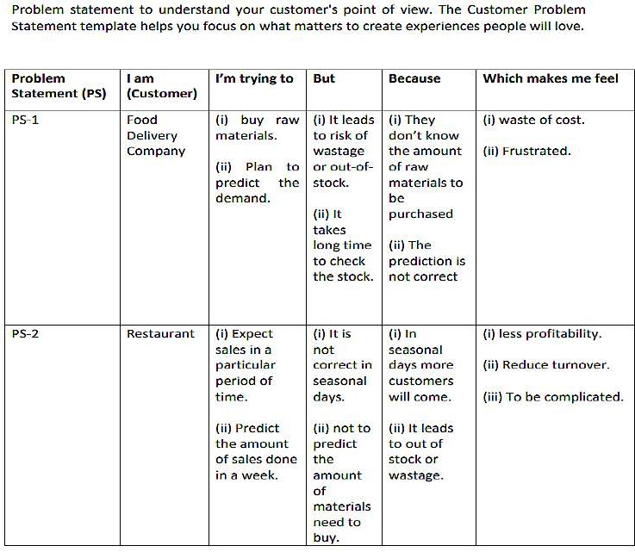

1. **IDEATION &PROPOSEDSOLUTION**

# Empathy Map Canvas

An empathy map is a collaborative visualization used to articulate what we know about a particular type of user. It externalizes knowledge about users in order to 1)create a shared understanding of user needs, and 2) aid in decision making.

Traditional empathy maps are split into 4 quadrants (Says, Thinks, Does, and Feels),with the user or persona in the middle.Empathy maps provide a glance into who a user Is as a who leand are not chronological or sequential.

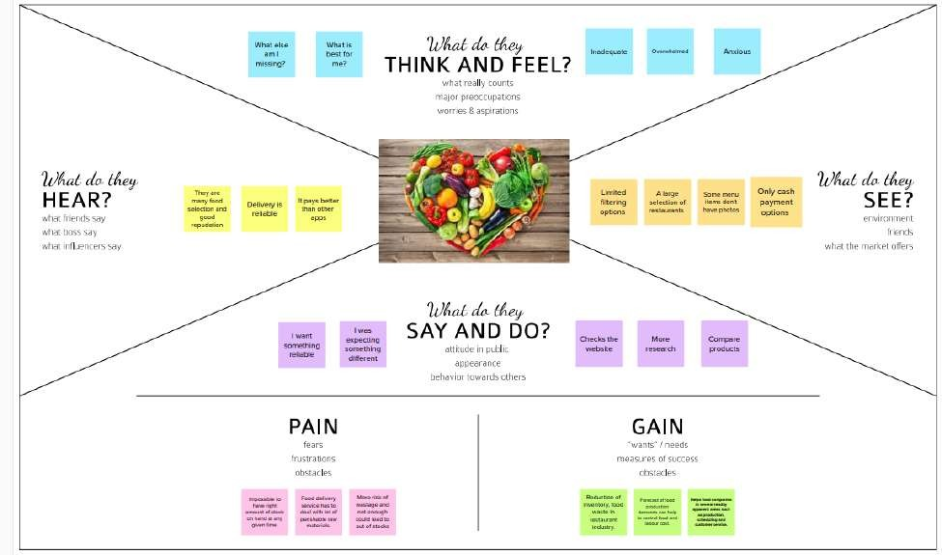

# Ideation & Brainstorming

Brainstorming is a method design teams use to generate ideas to solve clearlydeﬁned design problems. In controlled conditions and a free-thinking environment,teams approach a problem by such means as“How Might We”questions.They produce avast array of ideas and drawlinks between the mt of indpotential solutions

Everyoneinadesignteamshouldhavea*clear*deﬁnitionofthetargetproblem.Theytypicallygatherforabrainstormingsessioninaroomwithalargeboard/wallforpictures/Post-Its. A good mix of participants will expand the experience pool and there forebroadent he idea space.

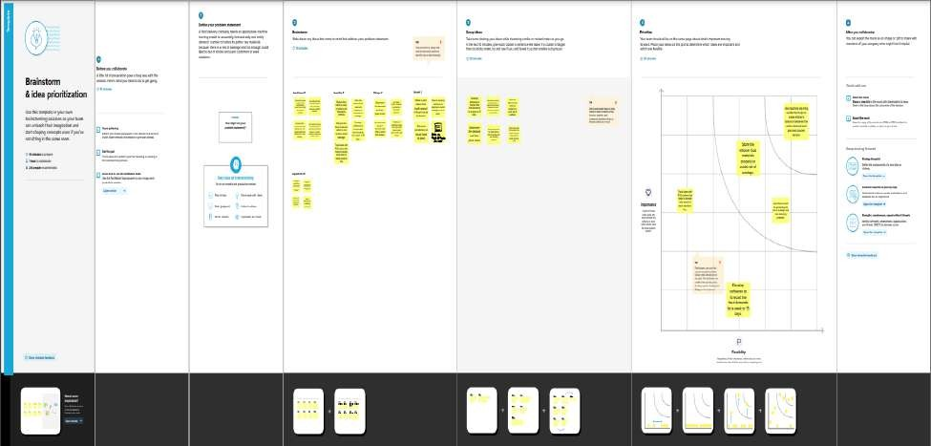

# 3.2ProposedSolution

[Proposed Solution](https://www.lawinsider.com/dictionary/proposed-solution) means the technical solution to be provided by the Implementation agency in response to the requirements and the objectives of the Project. [Proposed Solution](https://www.lawinsider.com/dictionary/proposed-solution) means the Proposed System with modiﬁcations that meet the Agency’s requirements as set forth in this RFP .[Proposed Solution](https://www.lawinsider.com/dictionary/proposed-solution) means the combination of software, hardware, other products or equipment, and any and all services (including any installation ,implementation, training, maintenance and support services)necessary to implement the solution described by Vendor in its Proposal.

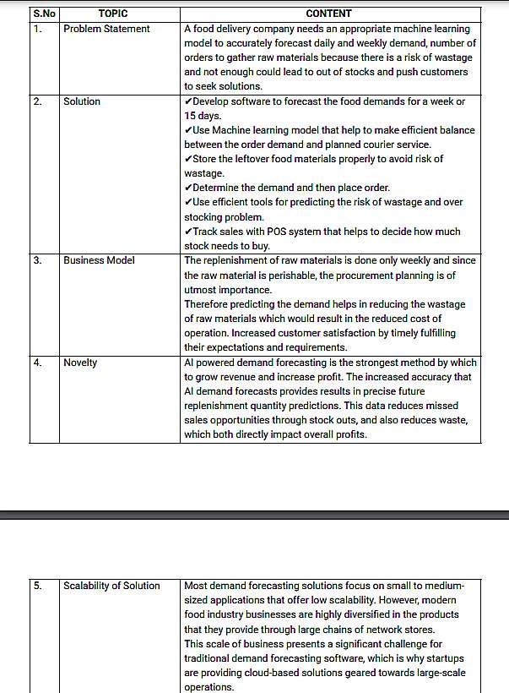

# 3.4ProblemSolutionFit

TheProblem-SolutionFitsimplymeansthatyouhavefoundaproblemwithyourcustomer and that the solution you have realized for it actually solves the customer'sproblem.

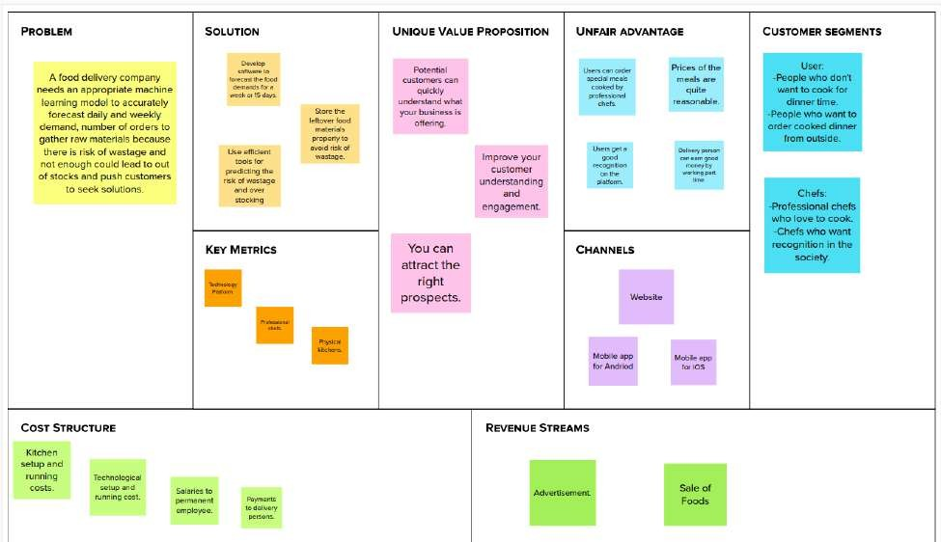

# REQUIREMENTANALYSIS

* 1. **Functional requirement**

Functional requirements may involve calculations, technical details, data manipulation and processing,and other speciﬁc functionality that deﬁne what a system is supposed to accomplish. Behavioral requirements describe all the cases where the system uses the functional requirements,these are captured in usecases.

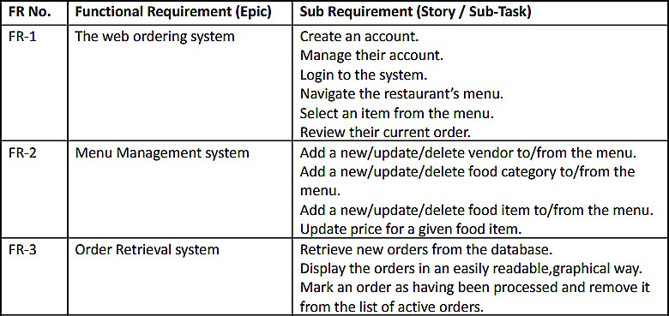

# Non-Functional requirements

In [systems engineering](https://en.wikipedia.org/wiki/Systems_engineering) and [requirements engineering](https://en.wikipedia.org/wiki/Requirements_engineering), a non-functional requirement(NFR)isa[requirement](https://en.wikipedia.org/wiki/Requirement)thatspeciﬁescriteriathatcanbeusedtojudgetheoperationofasystem,ratherthanspeciﬁcbehaviours.

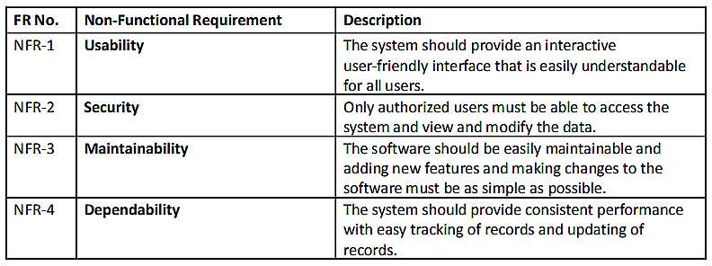

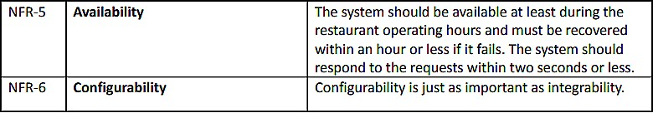

# PROJECTDESIGN

* 1. **Data Flow Diagrams**

A Data Flow Diagram (DFD) is a traditional visual representation of theinformationﬂowswithinasystem.AneatandclearDFDcandepicttherightamountofthe system requirement graphically. It shows how data enters and leaves the system,what changes the information, and where data is stored.

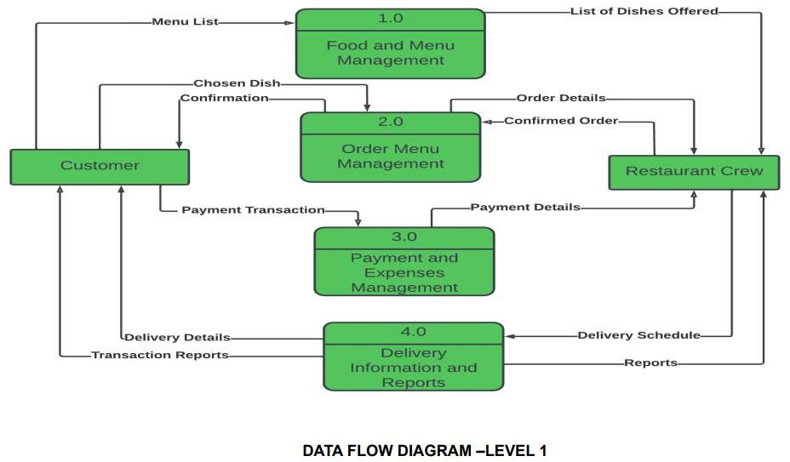

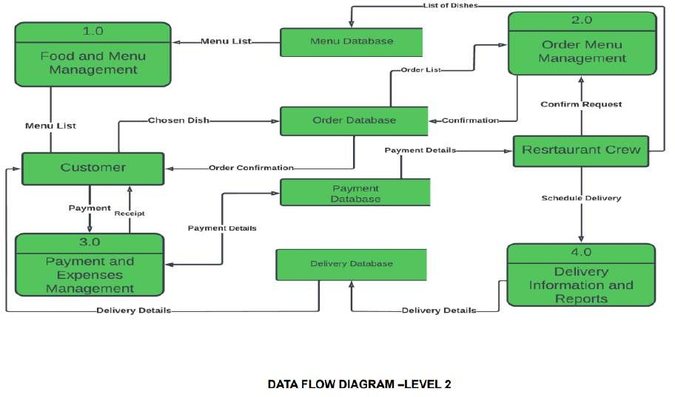

# Solution & Technical Architecture

Solution Architecture:

A solution architecture (SA)is an architectural description of a speciﬁc solution.

SAs combine guidance from different enterprise architecture viewpoints (business, information and technical),as well as from the enterprise solution architecture(ESA).

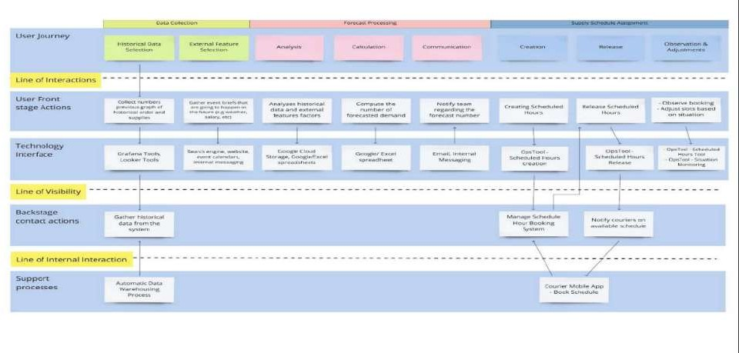

Technical Architecture:

Technical Architecture (TA) is a form of IT architecture that is used to designcomputersystems.Itinvolvesthedevelopmentofatechnicalblueprintwithregardtothe arrangement, interaction, and interdependence of all elements so that system-relevant requirements are met.

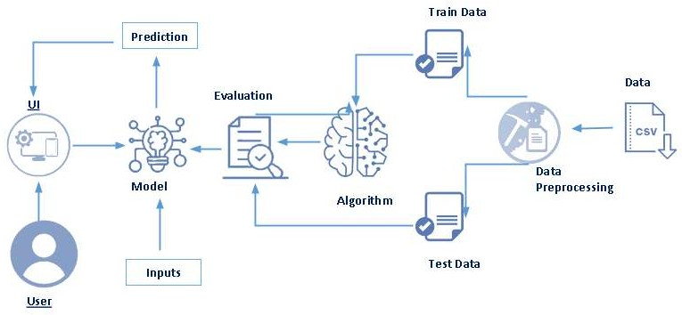

# User Stories

Auserstoryisaninformal,generalexplanationofasoftwarefeaturewrittenfromtheperspectiveoftheenduserorcustomer.Thepurposeofauserstoryistoarticulatehowapieceofworkwilldeliveraparticularvaluebacktothecustomer.

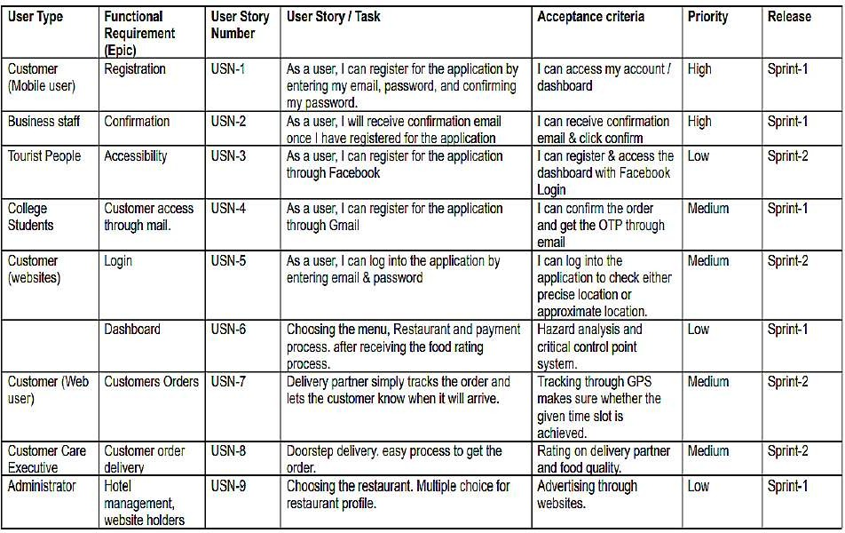

# PROJECTPLANNING&SCHEDULING

* 1. **Sprint Planning &Estimation**

In Scrum Projects, Estimation is done by the entire team during Sprint Planning Meeting .The objective of the Estimation would be to consider the User Stories for the Sprint by Priority and by the Ability of the team to deliver during the Time Box of the Sprint.

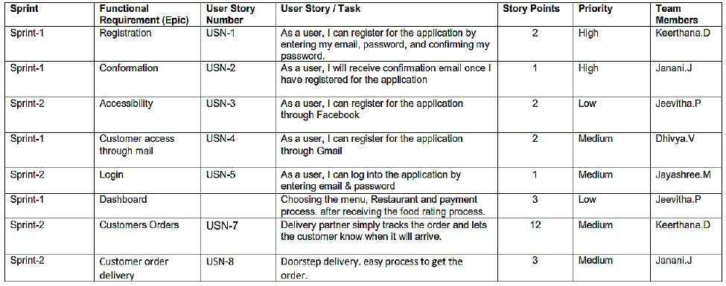

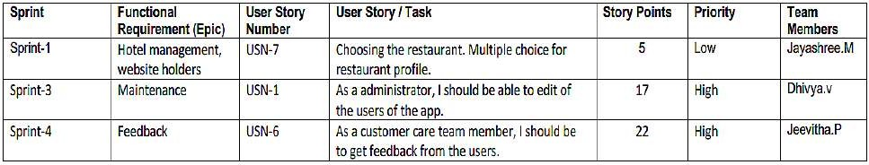

# Sprint Delivery Schedule

Asprintscheduleisadocumentthatoutlinessprintplanningfromendtoend.It'sone of the ﬁrst steps in the agile sprint planning process—and something that requires adequate research, planning, and communication.

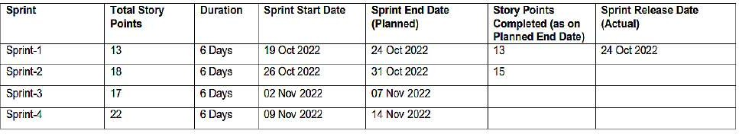

# Reports From JIRA

Jira helps teams plan, assign, track, report, and manage work and brings teamstogetherforeverythingfromagilesoftwaredevelopmentandcustomersupporttostart-upsandenterprises.SoftwareteamsbuildbetterwithJiraSoftware,the#1toolforagileteams.

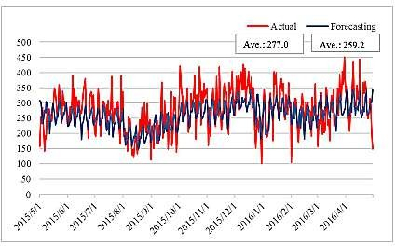

# CODING&SOLUTIONING

* 1. **Data Dictionary**

Ourbasedataconsistsoffourcsvﬁlescontaininginformationabouttestdata,traindataandotherrequiredinformation.

* + - train.csv: Contains information like id, week, center id, meal id, checkout price,baseprice,emailerforpromotion,homepagefeatured,numberoforders.Thisﬁleisusedfortraining.

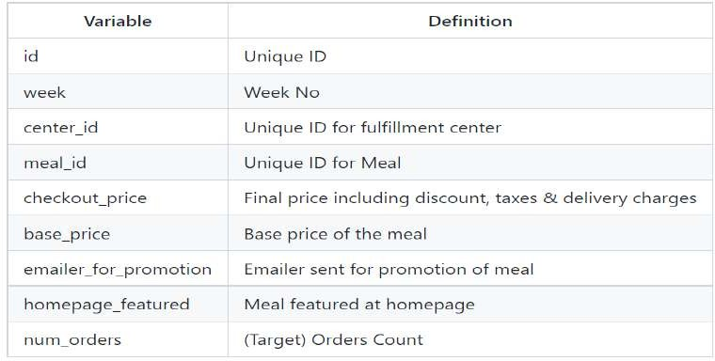

* + - test.csv:Containsinformationlikeid,week,centerid,mealid,checkoutprice,

baseprice,emailerforpromotion,homepagefeatured.Thisﬁleisusedfortesting.

* + - fulﬁlment_center_info.csv:Containsinformationofeachfulﬁlmentcenter.

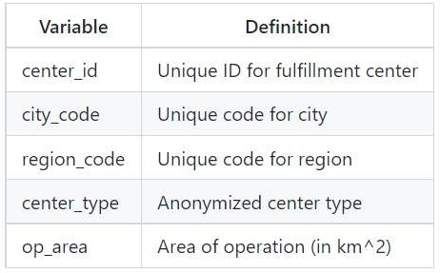

* + - meal_info.csv:Containsinformationofeachmealbeingserved.

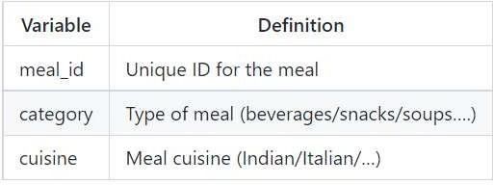

# Libraries Used

pandas,numpy,scikitlearn,matplotlib,seaborn,xgboost,lightgbm,catboost

# Data Pre-Processing

* + - There are noMissing/NullValuesinany of the there dataset.
    - Beforeproceedingwiththepredictionprocess,allthethreedatasheetsneedtobe merged into a single dataset. Before performing the merging operation,primaryfeatureforcombiningthedatasetsneedstobevalidated.
    - ThenumberofCenterIDsintraindatasetismatchingwiththenumberofCenterIDs in the Centers Dataset i.e 77 unique records. Hence, there won't be anymissingvalueswhilemergingthedatasetstogether.
    - ThenumberofMealIDsintraindatasetismatchingwiththenumberofMealIDsin the Meals Dataset i.e 51 unique records. Hence, there won't be any missingvalueswhilemergingthedatasetstogether.
    - Ascheckedearlier,therewerenoNull/Missingvaluesevenaftermergingthedatasets.

# Feature Engineering

Featureengineeringistheprocessofusingdomainknowledgeofthedatatocreatefeaturesthatimprovestheperformanceofthemachinelearningmodels.

Withthegivendata,Wehavederivedthebelowfeaturestoimproveourmodelperformance.

* + - DiscountAmount:Thisdeﬁnesthedifferencebetweenthe“base_Price”and“checkout_price”.
    - DiscountPercent:Thisdeﬁnesthe%discountoffertocustomer.
    - DiscountY/N:ThisdeﬁneswhetherDiscountisprovidedornot-1ifthereisDiscountand0ifthereisnoDiscount.
    - CompareWeekPrice:Thisdeﬁnestheincrease/decreaseinpriceofaMealforaparticularcentercomparedtothepreviousweek.
    - CompareWeekPriceY/N:Priceincreasedordecreased-1ifthePriceincreasedand0ifthepricedecreasedcomparedtothepreviousweek.
    - Quarter:Basedonthegivennumberofweeks,derivedanewfeaturenamedasQuarterwhichdeﬁnestheQuarteroftheyear.
    - Year:Basedonthegivennumberofweeks,derivedanewfeaturenamedasYearwhichdeﬁnestheYear.

# Data Transformation

* + - Logarithmtransformation(orlogtransform)isoneofthemostcommonlyusedmathematicaltransformationsinfeatureengineering.Ithelpstohandleskeweddata and after transformation, the distribution becomes more approximate tonormal.
    - Inourdata,thetargetvariable‘num_orders’isnotnormallydistributed.Usingthiswithoutapplyinganytransformationtechniqueswilldowngradetheperformanceofourmodel.
    - Therefore,wehaveappliedLogarithmtransformationonourTargetfeature‘num_orders’postwhichthedataseemstobemoreapproximatetonormaldistribution.
    - AfterLogtransformation,Wehaveobserved0%ofOutlierdatabeingpresentwithintheTargetVariable–num_ordersusing3IQRMethod.

# Evaluation Metric

Theevaluationmetricforthiscompetitionis100*RMSLEwhereRMSLEisRootofMeanSquaredLogarithmicErroracrossallentriesinthetestset.

# Initial Approach

* + - SimpleLinearRegressionmodelwithoutanyfeatureengineeringanddatatransformationwhichgaveaRMSE:194.402
    - Withoutfeatureengineeringanddatatransformation,themodeldidnotperformwellandcould'ntgiveagoodscore.
    - Postapplyingfeatureengineeringanddatatransformation(logandlog1ptransformation),LinearRegressionmodelgaveaRMSLEscoreof0.634.

# Advanced Models

* + - Withimprovisedfeatureengineering,builtadvancedmodelsusingEnsembletechniquesandotherRegressoralgorithms.
    - DecisionTreeRegressorsperformedwellonthemodelwhichgavemuchreducedRMSLE.
    - Withproperhyper-parametertuning,DecisionTreeRegressorperformedwellonthemodelandgavetheleaseRMSLEof0.5237

# TESTING

* 1. **Test Cases**

Atestcaseincludesinformationsuchasteststeps,expectedresultsanddatawhileatestscenarioonlyincludesthefunctionalitytobetested.

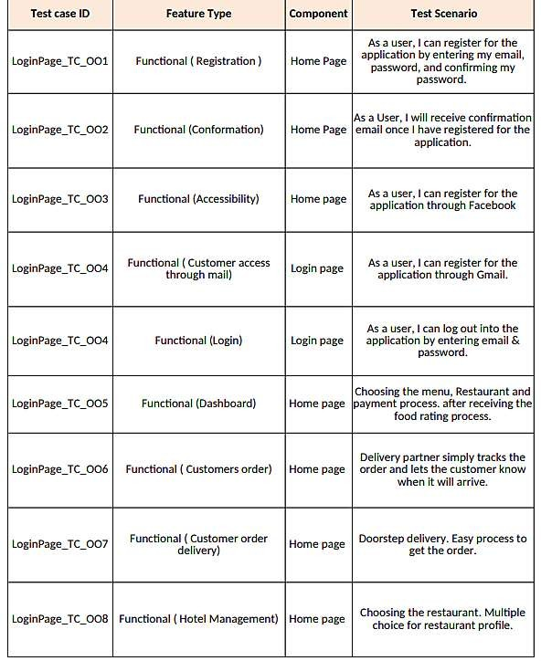

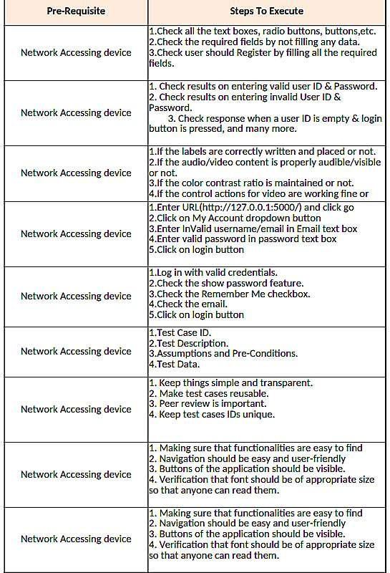

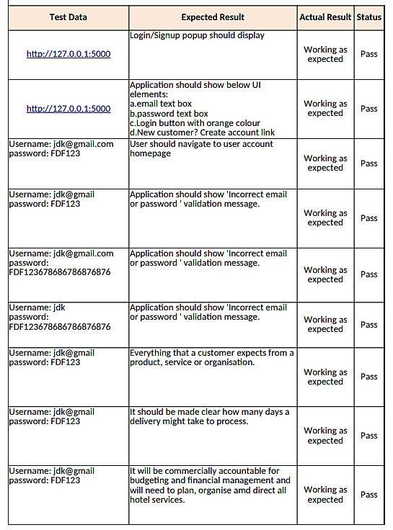

# User Acceptance Testing

User Acceptance Testing (UAT), which is performed on most UIT projects,sometimescalledbetatestingorend-usertesting,isaphaseofsoftwaredevelopmentinwhichthesoftwareistestedinthe"realworld"bytheintendedaudienceorbusinessrepresentative.

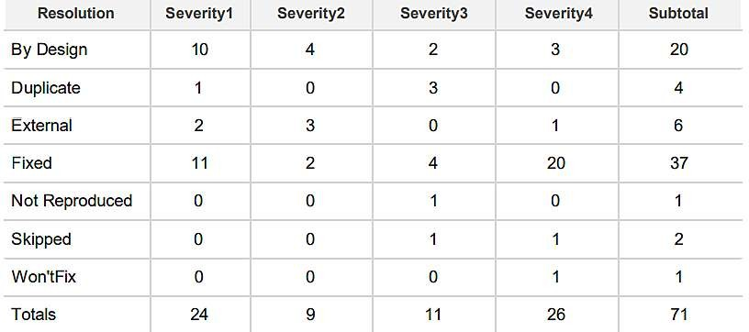DefectAnalysis:

TestCase Analysis:

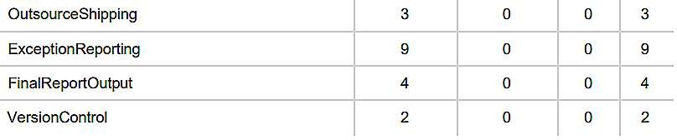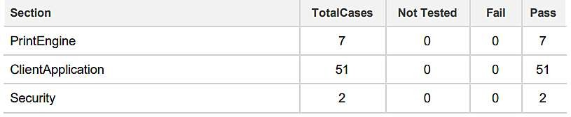

# RESULTS

* 1. **Performance Metrics**

Performance testing is the practice of evaluating how a system performs intermsofresponsivenessandstabilityunderaparticularworkload.Performancetestsaretypicallyexecutedtoexaminespeed,robustness,reliability,andapplicationsize.

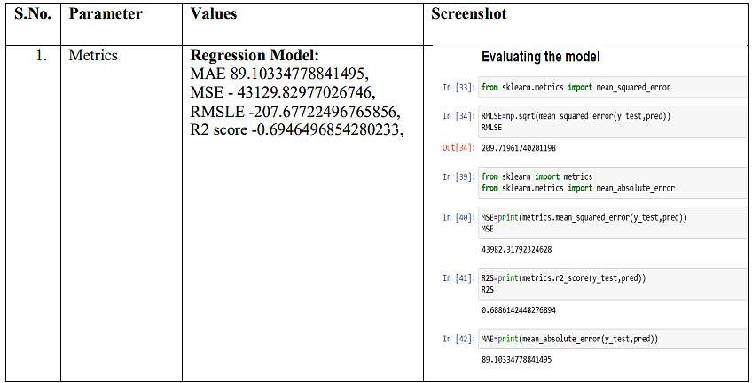

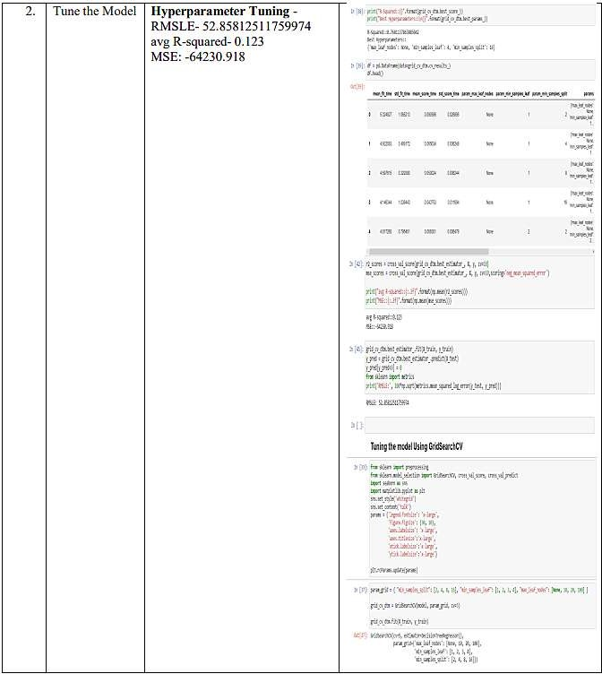

# ADVANTAGES&DISADVANTAGES

**Advantages:**

1. Foodwastagewillbeminimized.
2. Simpleandeasytouseframework.

# Disadvantages:

1.Theoutputobtainedmaynotbeprecised,duetotheuseoflimiteddatasets.

# APPLICATIONS

Thisprojectfocusesononefooddeliveryclient,whichdeliversfoodinmanydifferentcitiesthroughdistributionnetworksandfulﬁllmentcenters.

# CONCLUSION

Themainmotobehindthisprojectistoreducefoodwastage.Theavailabilityofthe food items makes the society better. Our purposed model would deﬁnitely comehandytoacompanyforpredictingthennumberoffoodordersandhelpthemtoservetheircustomersbetter.

# FUTURESCOPE

* 1. Working on the front end to make the frame work more dynamic.
  2. In the future,we also plant improve forecasting accuracy and research on the eﬃciency of store management.

# APPENDIX

**SOURCECODE**:

# home.html

<!DOCTYPEhtml>

<html>

<head>

<title>Home</title>

<style>

.navbar

{

margin: 0px;padding:20px;background-color:white;opacity:0.6;

color:black;

font-family:'Roboto',sans-serif;font-style:italic;

border-radius:20px;font-size:25px;

}

a

{

color:grey;ﬂoat:right;

text-decoration:none;font-style:normal;padding-right:20px;

}

a:hover{

background-color:black;color:white;

border-radius:15px;0font-size:30px;padding-left:10px;

}

p

{

color:white;font-style:italic;font-size:30px;

}

body

{

background-image:url("https://img.freepik.com/free-photo/grilled-chicken-rice-spicy-chickpeas-avocado-cabbage-pepper-buddha-bowl-dark-top-view_127032-1966.jpg?w=2000");

background-size:cover;

}

</style>

</head>

<body>

<divclass="navbar">

<ahref="/pred">Predict</a>

<ahref="/home">Home</a>

<br>

</div>

<br>

<center><b><fontcolor="yellow"size="15"font-family="ComicSansMS">FoodDemandForecasting</font></b></center>

<div>

<br>

<center>

<p>A food delivery service has to deal with a lot of perishable raw materials whichmakes it all, the most important factor for such a company is to accurately forecastdaily and weekly demand. Too much inventory in the warehouse means more risk ofwastage, and not enough could lead to out-of-stocks - and push customers to seeksolutionsfromyourcompetitors.Thereplenishmentofmajorityofrawmaterialsisdoneonweeklybasisandsincetherawmaterialisperishable,theprocurementplanningisofutmostimportance,thetaskistopredictthedemandforthenext10weeks.</p>

</center>

</div>

</body>

</html>

# upload.html

<htmllang="en">

<head>

<title>Predict</title>

<linkhref="https://cdn.bootcss.com/bootstrap/4.0.0/css/bootstrap.min.css"rel="stylesheet">

<style>

.bar

{

margin: 0px;padding:20px;background-color:white;opacity:0.6;

color:black;

font-family:'Roboto',sans-serif;font-style:italic;

border-radius:20px;font-size:25px;

}

a

{

color:red;ﬂoat:right;

text-decoration:none;font-style:normal;

padding-right:20px;

}

a:hover{

background-color:black;color:white;

border-radius:15px;0font-size:30px;padding-left:10px;

}

body

{

background-image:url("https://images.pexels.com/photos/1640777/pexels-photo-1640777.jpeg?cs=srgb&dl=pexels-ella-olsson-1640777.jpg&fm=jpg");

background-size:cover;

}

p

{

color:white;font-style:italic;font-size:30px;

}

h1,h2

{

color:0101DF;

}

</style>

</head>

<body>

<divclass="bar">

<ahref="/pred">Predict</a>

<ahref="/home">Home</a>

<br>

</div>

<divclass="container">

<center><divid="content"style="margin-top:2em">

<h2><center>FoodDemandForecasting</center></h2>

<formaction="{{url_for('predict')}}"method="POST">

<selectid="homepage_featured"name="homepage_featured">

<optionvalue="">homepage_featured</option>

<optionvalue="0">No</option>

<optionvalue="1">Yes</option>

</select><br><br>

<selectid="emailer_for_promotion"name="emailer_for_promotion">

<optionvalue="">emailer_for_promotion</option>

<optionvalue="0">No</option>

<optionvalue="1">Yes</option>

</select><br><br>

<inputclass="form-input"type="text"name="op_area"placeholder="Entertheop_area(2-7)"><br><br>

<selectid="cuisine"name="cuisine">

<optionvalue="">Cuisine</option>

<optionvalue="0">Continental</option>

<optionvalue="1">Indian</option>

<optionvalue="2">Italian</option>

<optionvalue="3">Thai</option>

</select><br><br>

<selectid="city_code"name="city_code">

<optionvalue="">CityCode</option>

<optionvalue="590">590</option>

<optionvalue="526">526</option>

<optionvalue="638">638</option>

<optionvalue="others">Others</option>

</select><br><br>

<selectid="region_code"name="region_code">

<optionvalue="">RegionCode</option>

<optionvalue="23">23</option>

<optionvalue="34">34</option>

<optionvalue="35">35</option>

<optionvalue="56">56</option>

<optionvalue="71">71</option>

<optionvalue="77">77</option>

<optionvalue="85">85</option>

<optionvalue="93">93</option>

</select><br><br>

<selectid="category"name="category">

<optionvalue="">Category</option>

<optionvalue="0">Beverages</option>

<optionvalue="1">Biryani</option>

<optionvalue="2">Desert</option>

<optionvalue="3">Extras</option>

<optionvalue="4">Fish</option>

<optionvalue="5">OtherSnacks</option>

<optionvalue="6">Pasta</option>

<optionvalue="7">Pizza</option>

<optionvalue="8">RiceBowl</option>

<optionvalue="9">Salad</option>

<optionvalue="10">Sandwich</option>

<optionvalue="11">Seafood</option>

<optionvalue="12">Soup</option>

<optionvalue="13">Starters</option>

</select><br><br>

<inputtype="submit"class="my-cta-button"value="Predict">

</form>

</center>

<br>

<h1class="predict">Numberoforders:{{prediction_text}}</h1>

</div>

</div>

</body>

</body>

# app.py

#importthenecessarypackagesimportpandasaspd

importnumpyasnpimportpickleimportos

from ﬂask import Flask,request, render_templateapp=Flask(name,template_folder="templates")@app.route('/',methods=['GET'])

defindex():

returnrender_template('home.html')@app.route('/home',methods=['GET'])defabout():

returnrender_template('home.html')@app.route('/pred',methods=['GET'])

def page():

return render_template('upload.html')@app.route('/predict',methods=['GET','POST'])defpredict():

print("[INFO]loadingmodel...")

model = pickle.load(open('fdemand.pkl', 'rb'))input_features=[ﬂoat(x)forxinrequest.form.values()]features_value = [np.array(input_features)]print(features_value)

features_name=['homepage_featured','emailer_for_promotion','op_area','cuisine','city_code','region_code','category']

prediction=model.predict(features_value)output=prediction[0]

print(output)

returnrender_template('upload.html',prediction_text=output)

ifname =='main':app.run(debug=False)

# OUTPUT SCREENSHOTS:

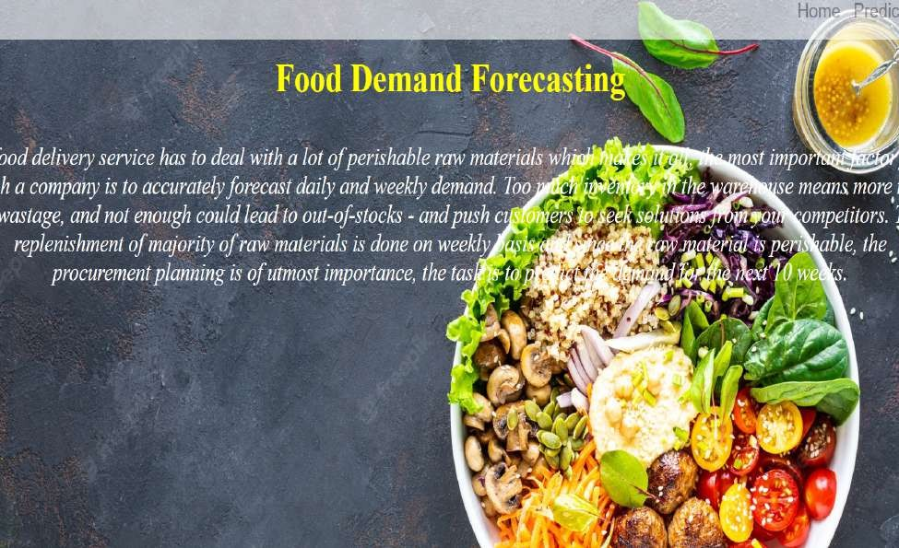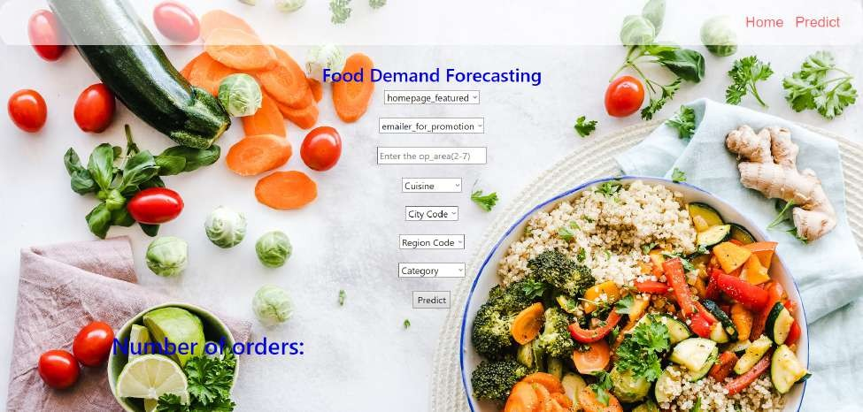

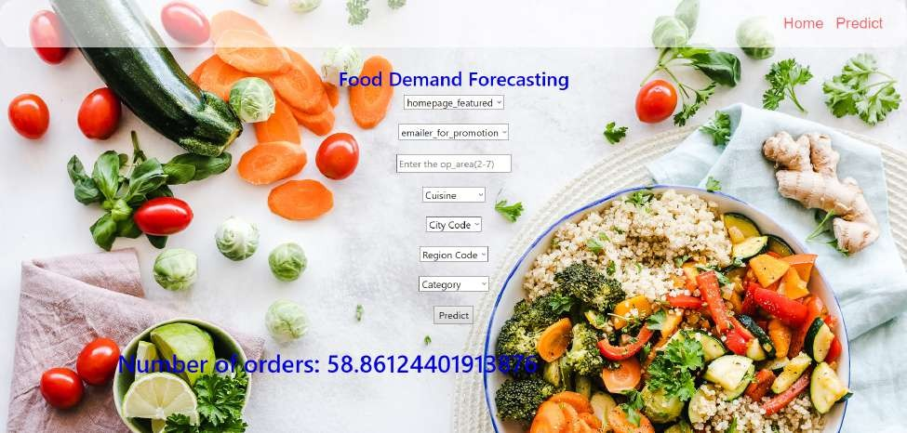

**GITHUBLINK:**

https://github.com/IBM-EPBL/**IBM-Project-39692-1660489566**.git